**WRONG**

<ul class="sidebar-nav">

<li class="sidebar-brand">

**<a href="#">**

Appliant

</a>

</li>

<li ng-repeat='cat in applicantList'>

**<a href="#"** ng-click='groupingAnsw2(cat)'> {{cat.TITLE}}</a>

</li>

</ul>

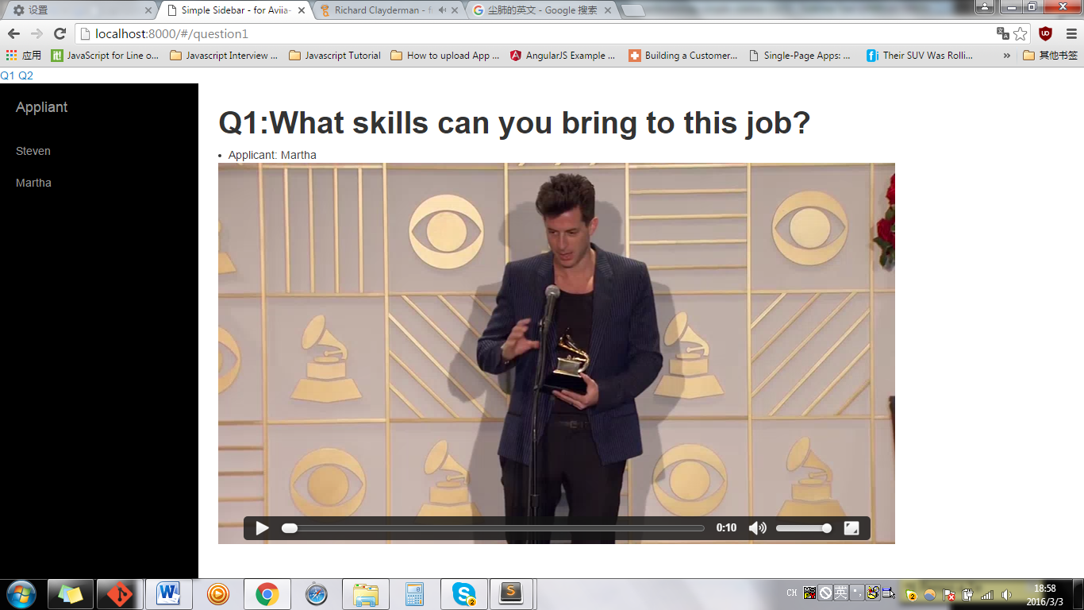

When click Steven, then jump to Q2? Why? Since  **<a href="#"> means Back**

**RIGHT**

<ul class="sidebar-nav">

<li class="sidebar-brand">

**<a href="">**

Appliant

</a>

</li>

<li ng-repeat='cat in applicantList'>

**<a href=""** ng-click='groupingAnsw2(cat)'> {{cat.TITLE}}</a>

</li>

</ul>